# ACTIVITY 04

## Question 1:

**READ FROM TWO FLAT FILES AND TWO TABLE FROM ANY SQL DATABASE**

# STEPS FOR ACTIVITY 3 QUESTION 1

1. USE THE SAME CSV FILES THAT WE USE IN THE ACTIVITY 3.
2. NOW CREATE 2 TABLES IN MYSQL AND INSERT DATA AS SHOWN BELOW USING THE SAME DATABASE activity03.
3. CREATE DATABASE TABLE FOR SSMS, ADD NEW ATTRIBUE PRIMARY KEY AS A NEW ATTRIBUTE (AUTO GENERATED).
4. OPEN VISUAL STUDIO AND COPY ACTIVITY3 PACKAGE AND RENAME IT for ACTIVITY4,NOW ADD ONE MORE ODBC SOURCE AND DATA CONVERSION, CONFIGURE IT AND LIKE WE DID IN ACTIVITY03 AND CONNECT IT WITH UNION ALL.

### STEP 1

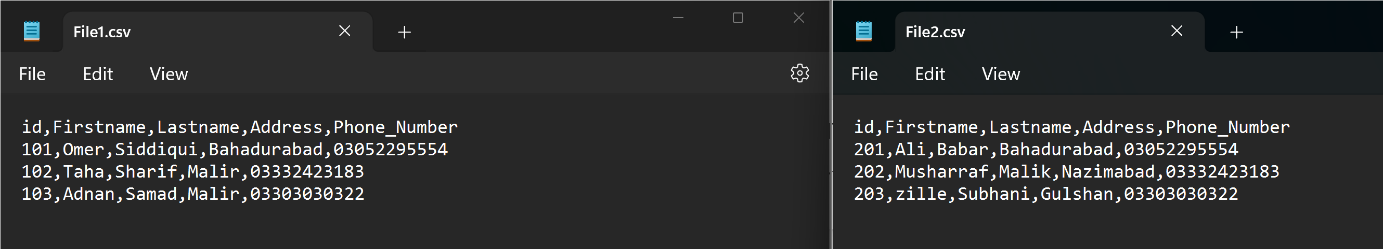

### STEP 2

-- create database DWass2;

use DWass2;

create table Activity4(

id int,

Firstname varchar(50),

Lastname varchar(50),

Address varchar(50),

Phone_Number varchar(11)

);

-- truncate table Activity4;

insert into Activity4(id,Firstname,Lastname,Address,Phone_Number) values(400,'BAig','Safdar','Bahadurabad','03052295554');

insert into Activity4(id,Firstname,Lastname,Address,Phone_Number) values(401,'Irfan','junejo','Gulshan','03052456443');

insert into Activity4(id,Firstname,Lastname,Address,Phone_Number) values(402,'Saad','Hussain','PIB','03003982773');

select * from Activity4;

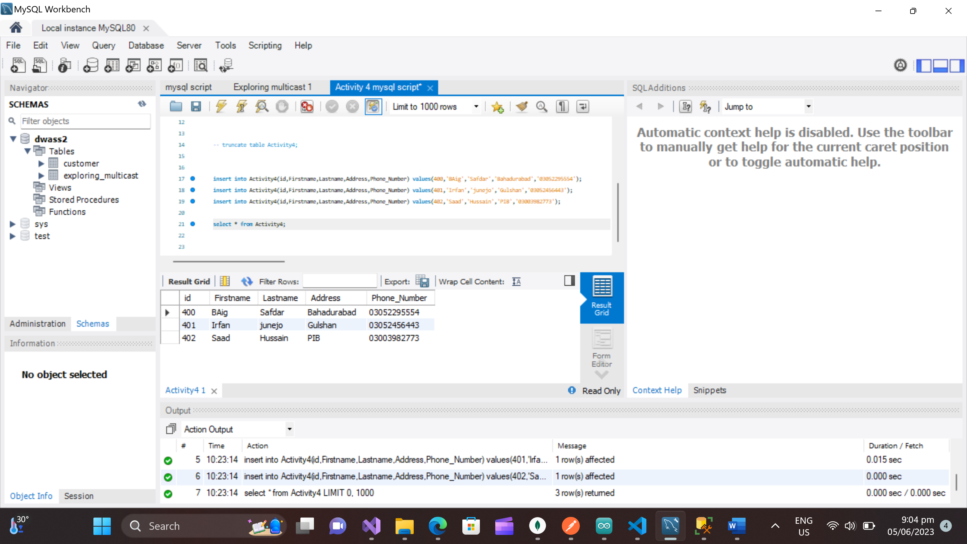

create database DWass2;

use DWass2;

create table Customer(

id int,

Firstname varchar(50),

Lastname varchar(50),

Address varchar(50),

Phone_Number varchar(11)

);

-- truncate table customer;

insert into customer(id,Firstname,Lastname,Address,Phone_Number) values(300,'Omer','Siddiqui','Bahadurabad','03052295554');

insert into customer(id,Firstname,Lastname,Address,Phone_Number) values(301,'Ahsan','Amir','Gulshan','03052456443');

insert into customer(id,Firstname,Lastname,Address,Phone_Number) values(302,'Faaiz','Faroqi','PIB','03003982773');

select * from customer;

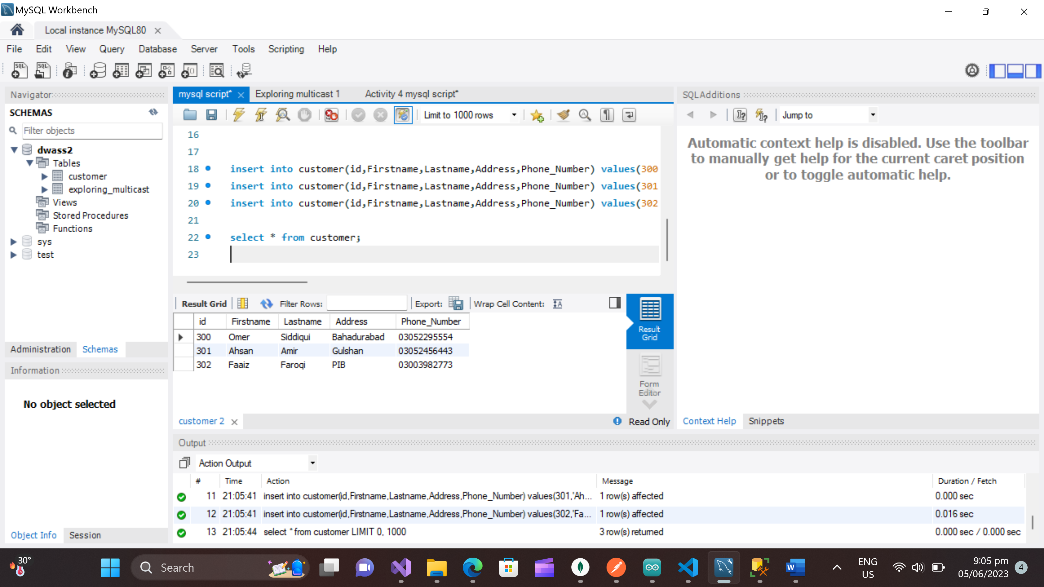

### STEP 3

--create database [DWH assignment];

use [DWH assignment ];

create table dbo.Customers(

id int,

Firstname varchar(50),

Lastname varchar(50),

Address varchar(50),

Phone_Number varchar(11)

);

select * from dbo.Customers;

-- truncate table dbo.Customers;

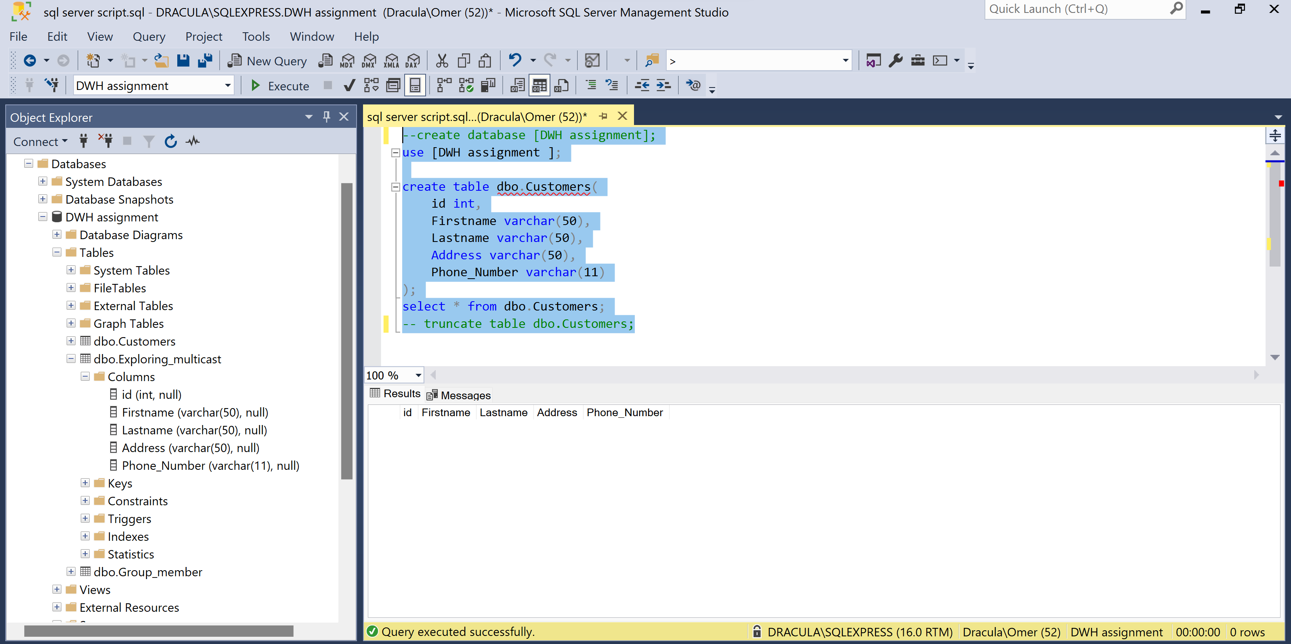

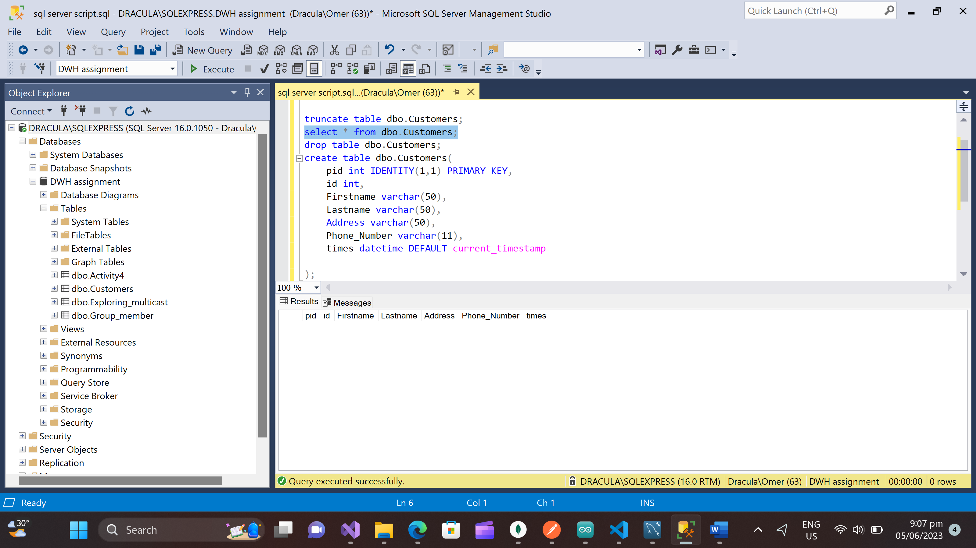

### STEP 4

